Minor Project Report on

# VEHICLE NUMBER PLATE DETECTOR

Submitted in partial fulfillment of the requirements for the award of degree of

# Bachelor of Technology

in

# Computer Engineering

by

**DHRUV**

**19001003039**

**ASHISH**

**19001003022**

Under supervision of

# DR KOMAL BHATIA



**Department of Computer Engineering**

**J. C. BOSE UNIVERSITY OF SCIENCE & TECHNOLOGY, YMCA FARIDABAD-121006**

# August 2021

**TABLE OF CONTENTS**

* Introduction
* Acknowledgement
* Abstract
* Problem statement
* Future prospectives
* Functional requirements and implementation
* Conclusion

Dr komal Bhatia sir

(Supervisor) Assistant Professor, Department of Computer Engg,

J. C. Bose University of Science and Technology, YMCA, Faridabad

## ACKNOWLEDGEMENT

**We had a great experience working on this project and we got to learn about new skills through this project. However, it would not have been possible without a kind support and**

**help of many individuals. We would like to extend our sincere thanks to all of them. We are highly indebted to the teacher**

**and especially Dr Komal Bhatia for their guidance and constant supervision as well as providing necessary information regarding the project and also for their support in completing the project.**

**ABSTRACT**

**The project aims to develop a software which helps in detecting the number plate of any vehicle . It has been designed to provide a user friendly interface for carrying out a variety of tasks by employing certain well defined commands or using keyboard input**

PROBLEM STATEMENT

The system of vehicle number plate detection and recognition is used to **detect the plates** then make the recognition of the plate that is to extract the text from an image and all that thanks to the calculation modules that use location algorithms, segmentation plate and character recognition

**Purpose**  It is a technology that uses [optical character recognition](https://en.wikipedia.org/wiki/Optical_character_recognition) on images to read [vehicle registration plates](https://en.wikipedia.org/wiki/Vehicle_registration_plate) to create [vehicle location data](https://en.wikipedia.org/wiki/Vehicle_location_data). It can use existing [closed-circuit television](https://en.wikipedia.org/wiki/Closed-circuit_television), [road-rule enforcement cameras](https://en.wikipedia.org/wiki/Road-rule_enforcement_camera), or cameras specifically designed for the task. ANPR is used by police forces around the world for law enforcement purposes, including to check if a [vehicle is registered](https://en.wikipedia.org/wiki/Vehicle_registration) or [licensed](https://en.wikipedia.org/wiki/Vehicle_licence). It is also used for [electronic toll collection](https://en.wikipedia.org/wiki/Electronic_toll_collection) on [pay-per-use roads](https://en.wikipedia.org/wiki/Road_pricing) and as a method of cataloguing the movements of traffic, for example by highways agencies.

Numpy

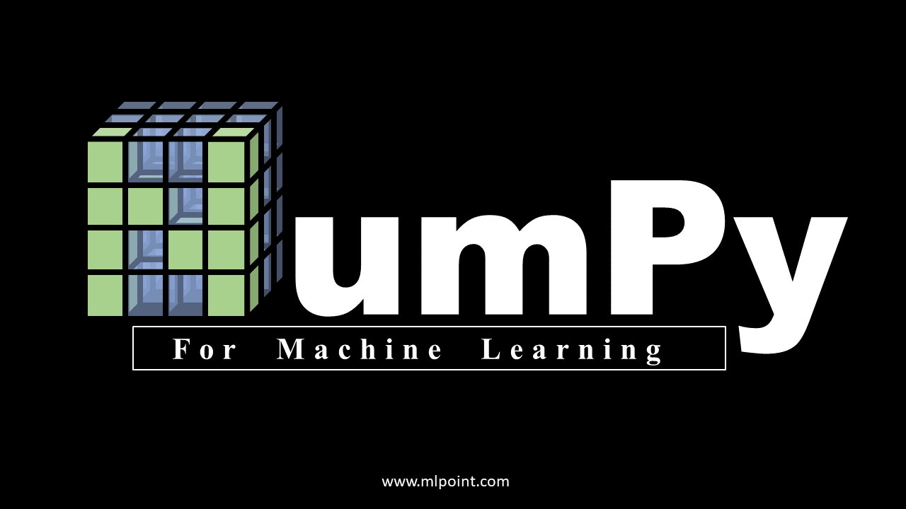

NumPy library is an important foundational tool for studying Machine Learning. Many of its functions are very useful for performing any mathematical or scientific calculation. As it is known that mathematics is the foundation of machine learning, most of the mathematical tasks can be performed using NumPy.

Pandas



pandas is a software library written for the Python programming language for data manipulation and analysis. In particular, it offers data structures and operations for manipulating numerical tables and time series. It is free software released under the three-clause BSD license.[2] The name is derived from the term "panel data", an econometrics term for data sets that include observations over multiple time periods for the same individuals.[3] Its name is a play on the phrase "Python data analysis" itself.[4] Wes McKinney started building what would become pandas at AQR Capital while he was a researcher there from 2007 to 2010.[5]

Tensorflow



TensorFlow is a free and open-source software library for machine learning. It can be used across a range of tasks but has a particular focus on training and inference of deep neural networks. Tensorflow is a symbolic math library based on dataflow and differentiable programming.

Pynumpy



NumPy is a library for the Python programming language, adding support for large, multi-dimensional arrays and matrices, along with a large collection of high-level mathematical functions to operate on these arrays.

Matplot Library

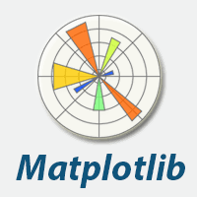

Matplotlib is a comprehensive library for creating static, animated, and interactive visualizations in Python.

screenshotsscreenshotsscreenshotsscreenshots

Matplotlib makes easy things easy and hard things possible.

Create

Develop publication quality plots with just a few lines of code

Use interactive figures that can zoom, pan, update...

Customize

Take full control of line styles, font properties, axes properties...

Export and embed to a number of file formats and interactive environments

Extend

Explore tailored functionality provided by third party packages

Learn more about Matplotlib through the many external learning resources

Pytesseract



Pytesseract is a Python package that works with tesseract, which is a command-line optical character recognition (OCR) program. It's a super cool package that can read the text contained in pictures. Let's get to it.

OpenCV

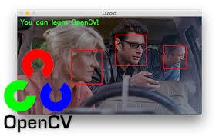

OpenCV (Open Source Computer Vision Library) is an open source computer vision and machine learning software library. OpenCV was built to provide a common infrastructure for computer vision applications and to accelerate the use of machine perception in the commercial products. Being a BSD-licensed product, OpenCV makes it easy for businesses to utilize and modify the code.

The library has more than 2500 optimized algorithms, which includes a comprehensive set of both classic and state-of-the-art computer vision and machine learning algorithms.

Functional requirements and implementation

1. Convert The Image Into GrayScale Image

Converting into grayscale image speeds up the other process which is implemented in our project later because after removing color we do not have to deal with the color details when we processing an image

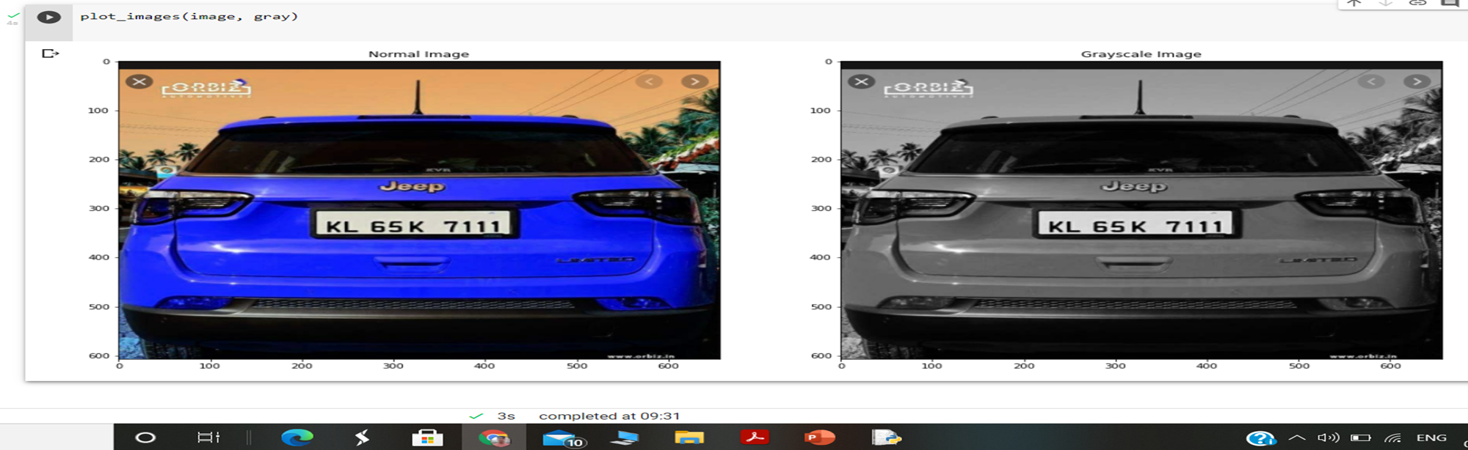

1. **Using a bilateral filter**

In our project we use the bilateral filter which helps to remove the unwanted detail of the image. By using this our project later on focus only useful regions

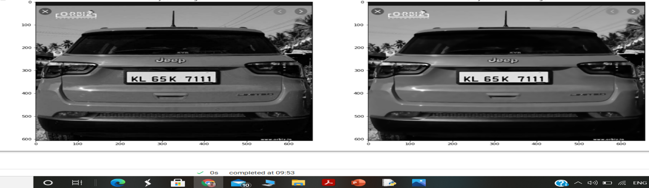

1. **Edge detection**

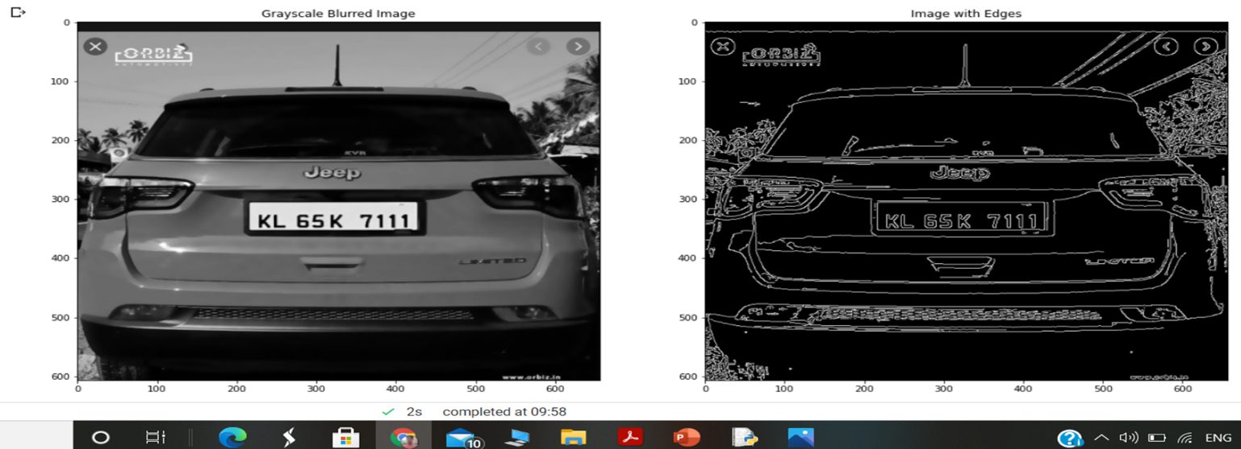

1. **Contour detection**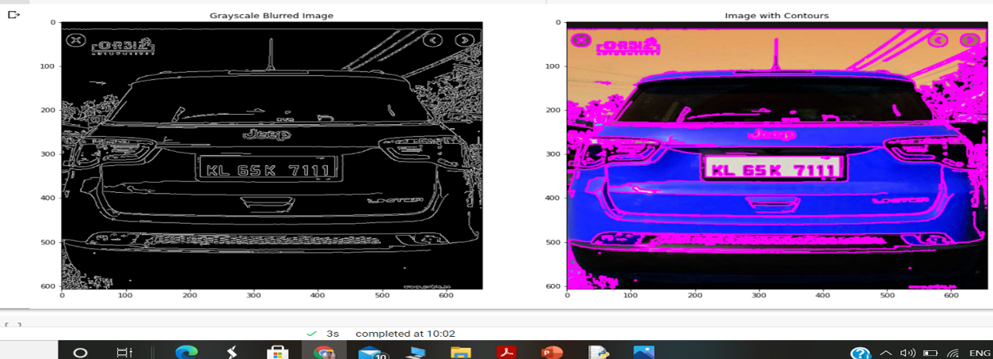
2. **Sorted top 10 contours**

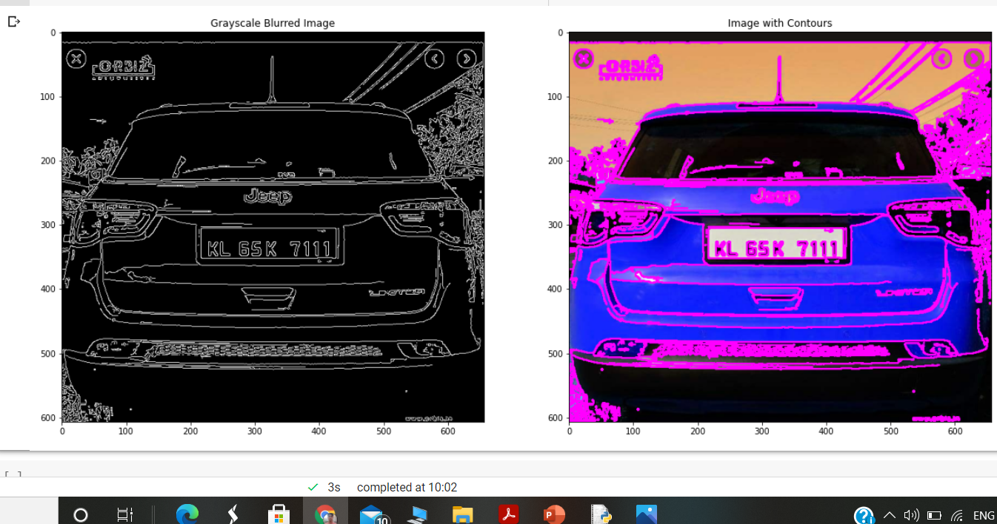

1. **Final plate detection**

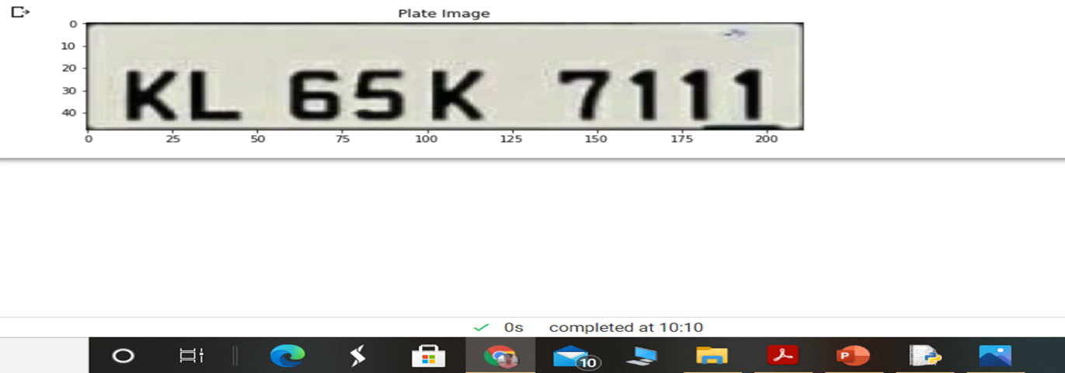

**CONCLUSION**

There is an immediate need of such kind of Automatic Number Plate Recognition System in India as there are problems of traffic, stealing cars etc.

Government should take some interest in developing this system as this system is very economical and eco-friendly,if applied effectively.

This change will help in the progress of the Nation.